**EXERCISE-1: INSERTION SORT**

**PRATEEK MOHANTY**

**20BCE1482**

* **ARRAY METHOD**

// array_method

#include <iostream>

using namespace std;

int main()

{

    int elements[20], key, i, j, n;

    cout << "Enter number of elements";

    cin >> n;

    for (i = 0; i < n; i++)

        cin >> elements[i];

    for (j = 1; j < n; j++)

    {

        key = elements[j];

        i = j - 1;

        while ((i >= 0) && (elements[i] > key))

        {

            elements[i + 1] = elements[i];

            i = i - 1;

        }

        elements[i + 1] = key;

    }

    for (i = 0; i < n; i++)

    {

        cout << elements[i] << " ";

    }

}

OUTPUT

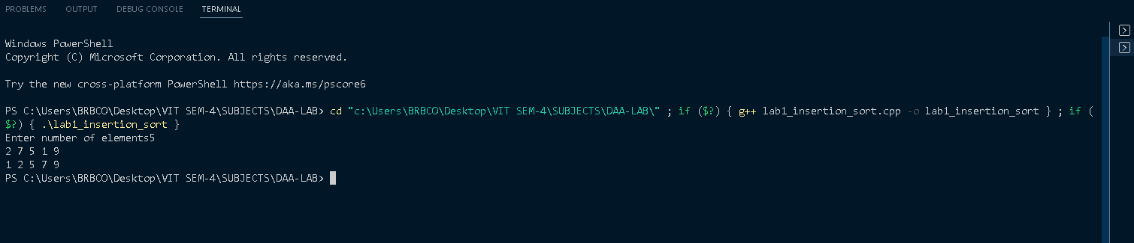

**2. Insertion Sort using Vector**

**CODE**

#include <iostream>

#include <vector>

using namespace std;

int main()

{

    vector<int> elements(20, 0);

    int key, i, j, n;

    cout << "Enter number of elements";

    cin >> n;

    for (i = 0; i < n; i++)

        cin >> elements[i];

    for (j = 1; j < n; j++)

    {

        key = elements[j];

        i = j - 1;

        while ((i >= 0) && (elements[i] > key))

        {

            elements[i + 1] = elements[i];

            i = i - 1;

        }

        elements[i + 1] = key;

    }

    for (i = 0; i < n; i++)

    {

        cout << elements[i] << " ";

    }

}

**OUTPUT**



* **POINTER CLASS**
* #include <bits/stdc++.h>
* using namespace std;
* class point
* {
* int x, y;
* public:
* bool operator>(point);
* friend istream &operator>>(istream &, point &);
* friend ostream &operator<<(ostream &, point &);
* };
* bool point::operator>(point p)
* {
* float dis1, dis2;
* dis1 = sqrt(x * x + y * y);
* dis2 = sqrt(p.x * p.x + p.y * p.y);
* return (dis1 > dis2);
* }
* istream &operator>>(istream &in, point &p)
* {
* in >> p.x >> p.y;
* return in;
* }
* ostream &operator<<(ostream &out, point &p)
* {
* out << p.x << " " << p.y << endl;
* return out;
* }
* int main()
* {
* vector<point> elements;
* point key, ele;
* int i, j, n;
* cout << "Enter number of elements: ";
* cin >> n;
* for (i = 0; i < n; i++)
* {
* cin >> ele;
* elements.push_back(ele);
* }
* for (j = 1; j < n; j++)
* {
* key = elements[j];
* i = j - 1;
* while ((i >= 0) && (elements[i] > key))
* {
* elements[i + 1] = elements[i];
* i = i - 1;
* }
* elements[i + 1] = key;
* }
* for (i = 0; i < n; i++)
* {
* cout << elements[i] << " ";
* }
* }

**OUTPUT**

